Alex Casanova Muñoz

Data Governance Experience

Business Data Analyst application

Data Governance

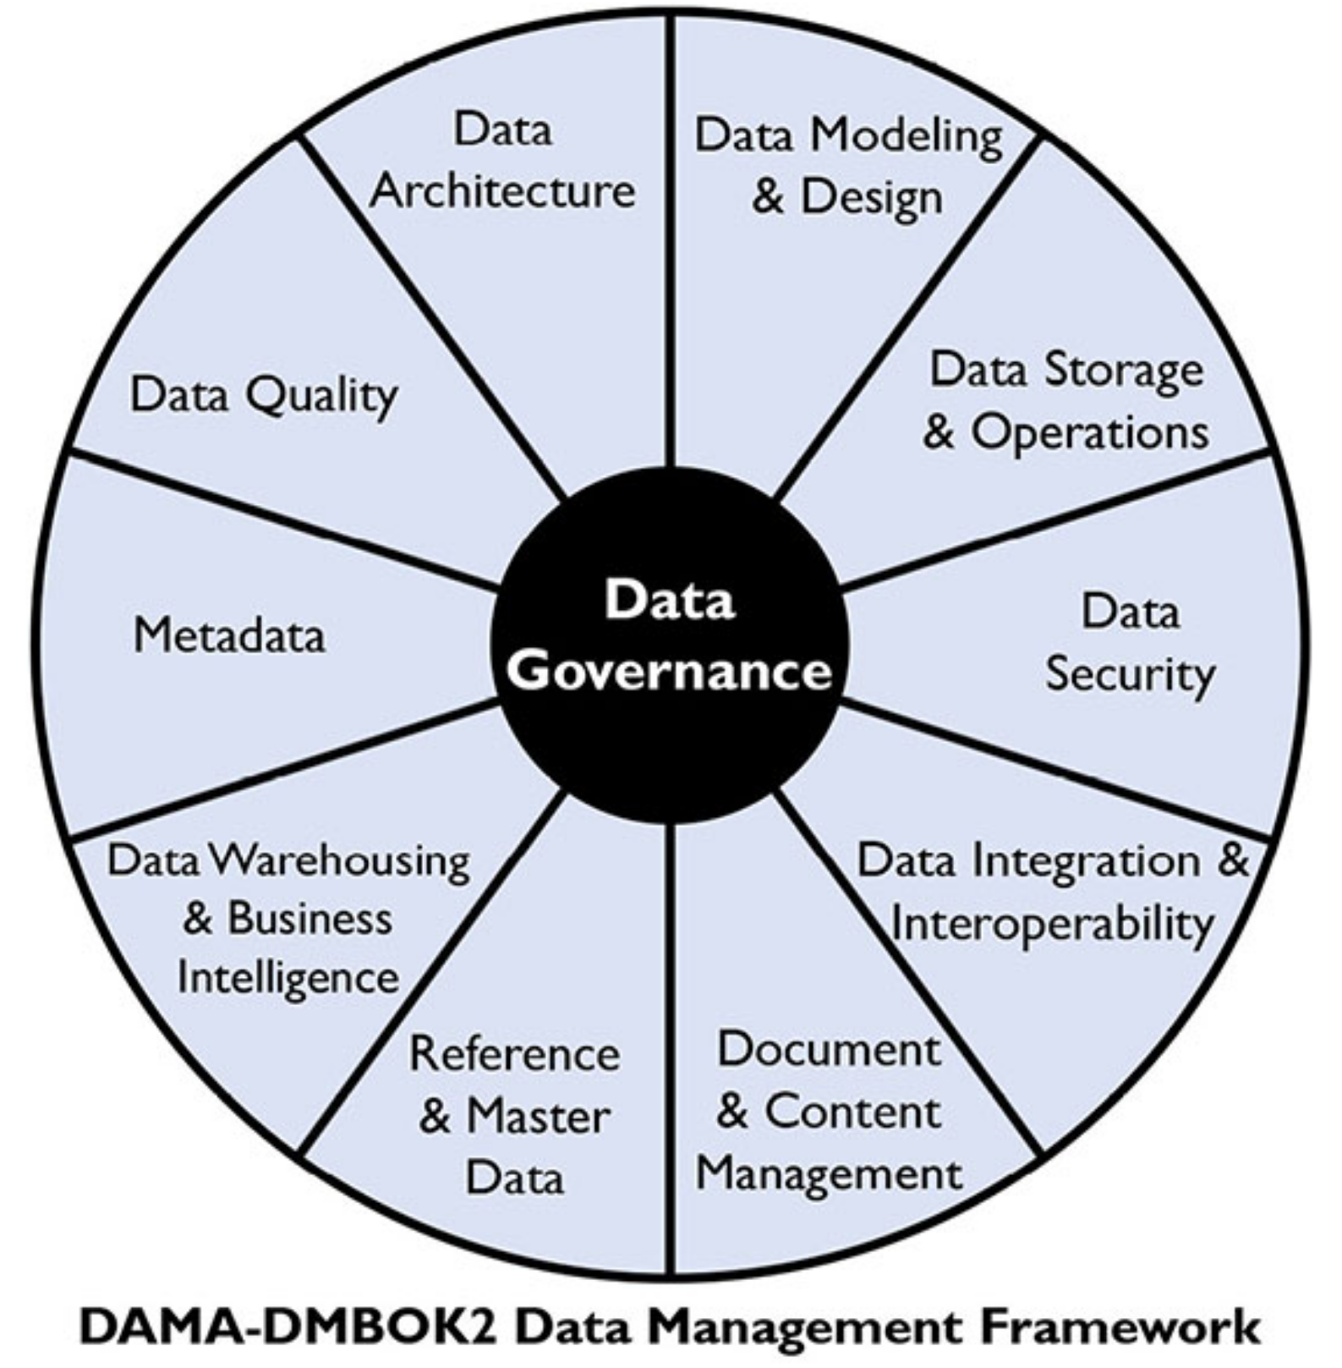

**Work Experience**.

During my experience at Scotiabank working in different analytical projects (Churn prediction, Fraud detection, Money laundering and Customer segmentation), all of them were managed and developed under two key aspects of a data governance, data quality and metadata management.

Regarding the data quality the key function was to execute a Data Quality Report were data quality assessments, including metrics such as completeness, accuracy, consistency, and timeliness performed to the tables with raw data.

Finally, for the metadata management the principal function was creating a metadata repository containing metadata definitions, descriptions, and attributes for all data assets within the organization, providing a unified view of the data landscape.

**Academic Experience**.

I’m currently finishing my thesis for my Master degree of Business Analytics at Rosario University. My thesis proposes an analytic solution to leverage decision making and value offering of a Colombian IT organization and a key aspect for the success of this proposal is the implementation of Data Governance that guarantees the quality of the data.

These are the Data Governance aspects implemented for the Colombian IT organization, based on the Data Management Association (DAMA):

* Data Governance Framework Development: Establishing a formal Data Governance framework that outlines the organizational structure, roles, responsibilities, policies, and procedures related to data management.
* Data Stewardship: Assigning a data steward responsible for managing specific data domains or elements throughout their lifecycle.
* Data Quality Management: Ensuring that data is accurate, complete, consistent, and conforms to predefined quality standards.
* Metadata Management: Managing metadata to provide context and understanding of data assets, including their lineage, definitions, relationships, and usage.
* Data Security and Privacy: Ensuring that data is protected from unauthorized access, disclosure, alteration, or destruction, and that privacy regulations are adhered to.
* Data Lifecycle Management: Managing the lifecycle of data from creation or acquisition to archival or deletion.